Dessa Shapiro

4/29/20

Period 4&6

Journey

I’m reading the book *Into Thin Air* by Jon Krakauer about a journalist who decides to climb Mount Everest with a group and track their journey. So far in the plot of the text, I’m at the end of the rising action because he is about to reach the top of Mount Everest. I noticed that this book is very descriptive and the author used targeted language to appeal to the reader and express his experiences. I found in the text that in certain parts when he is describing the actual climbing and experience on the mountain he uses a lot of descriptive languages and more figurative language. Which gives the writing more illustration and holds most of the symbolism. While in other parts of the text when he is describing his or other past experiences he doesn't use as many descriptive words. The writing is more directed towards an analytical and observational tone. “ For the first time on the expedition, the vista was primarily sky rather than earth. Herds of puffy cumulus raced beneath the sun, imprinting the landscape with a shifting matrix of shadow and blinding light.”(pg.143) I found this quote to be a good example of the different figurative language the author uses. The particular word choice or this section stood out to me and I was able to visualize the scene very well.

*Into Thin Air* is about and written by Jon Krakauer. From reading the book so far it’s obvious that he has a great passion for climbing and feels a great pull to adventure. We learn that he grew up climbing and as a young adult he would go on climbing expeditions and spend a lot of time in the mountains. He has gone on many different journeys and mentions a few of them in his book as he reflects on himself. I can see that when he is talking about his group on the climb or past climbs he gets some of his motivation from others and values his relationships with other climbers. Sometimes when I’m reading the parts where he talks about other authors it seems that he looks up to them or pushes himself to keep up with them. “ My first impression of Beck had not been favorable… Yet the better I got to know him, the more he earned my respect. Even though his inflexible new boots had chewed his feet into hamburger...And what I initially took to be arrogance was looking more and more like exuberance.”(pg.140) The author, much like this quote mentions many different climbers and shares his experiences with them. This also allows me to trust him more because I see that he is judging people which makes him seem more human and relatable.

I can notice a lot of interesting aspects of the book so far as the reading and the interesting literary strategies and how the writer is expressing himself and trying to engage the audience by having the reader be able to empathize or sympathize with his experiences. And bring them into the story with him, While reading I’ve ever felt like I could perfectly picture what was happening on that mountain with him. But overall I’ve found it hard to fully relate with him through the book. It’s as if when I’m reading I can find these small moments that pull me into the story but I have yet to have that one big push where I can’t wait to turn the page and find out what happens next. I did enjoy the moments when I got to know more about the author's perspective in comparison to others. “Chen’s death cast a pall over the mountain as rumors of the accident spread from tent to tent, but thirty-three climbers would be departing for the summit in a few short hours, and the gloom was quickly banished by nervous anticipation of what lay ahead.”(pg.163) This passage is an example of how I’ve found it difficult to connect to the text. He’s talking about the previous day and it seems that he is overlooking someone's death and only anticipating the final climb or the mountain. And I realized that I don’t understand that perspective of having so much passion for something that everything else fades away. I’m a practical person and I could never imagine putting myself in that much danger or the draw of climbing a mountain. So, I can respect the writing and his experience but I can not understand it.

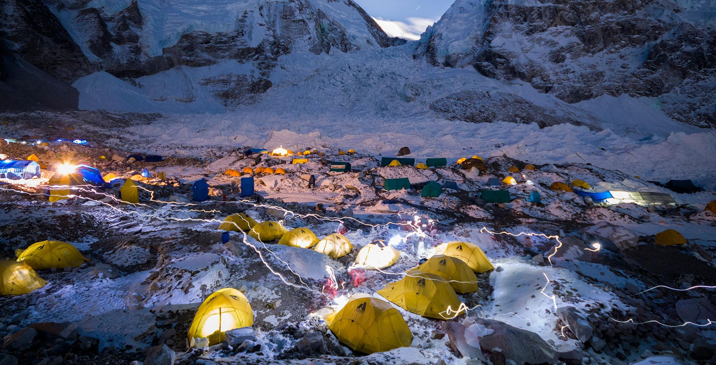A picture from Everest